lgplogo2c

***YOUTH SUMMER CONTACT FOOTBALL CAMP***

Dates: Monday July 21- Thursday, July 24 Times: 5:30pm-7:30pm

* Location: ECAV Stadium- RPI Campus - A state of the art 5000 seat facility with lighted turf field  
  **Parents ARE WELCOME TO OBSERVE FROM THE STANDS!!**

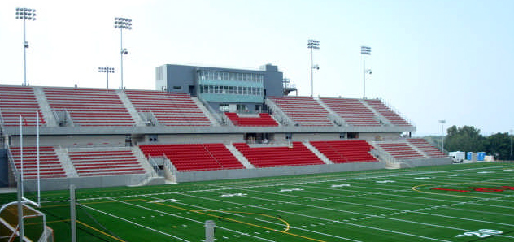

**Enrollment Information:**

* + FOR GRADES 3-8; male and female welcome in this camp!
  + Limited space- registrations are accepted on a first come, first serve basis---ENROLL EARLY!!
  + You may register a team for a discount off of each member! Consult Alicia Randazzo, Program Administrator, for details at 518-276-6809 or [randaa2@rpi.edu](mailto:randaa2@rpi.edu)
  + Cost: $120 per camper. There is also a $4.95 fee per credit card transaction. YOU MAY ALSO PAY BY CHECK!

***Football Camp Basics:***

The camp goal is to provide an introduction and/or development of football blocking, tackling, catching, throwing, and kicking skills. These will all be taught by position. Each camper will have the opportunity to play and learn both successful offensive and defensive skills and techniques from RENSSEALER VARSITY FOOTBALL COACHES!!  
  
**Participants must bring with them:** NOCASE APPROVED EQUIPMENT (a helmet, shoulder pads, mouth guard, and proper footwear. Full pads will be needed for days 3 and 4. Please bring your own water bottle!) You must also provide two practice jerseys: 1 white and 1 one of any color.

***In the event you may have any questions or concerns, please contact Alicia Randazzo at 518-276-6809 at the Summer@Rensselaer office.***

**Registration:**

http://summer.rpi.edu/update.do?catcenterkey=16